DATE: 25.10.2019
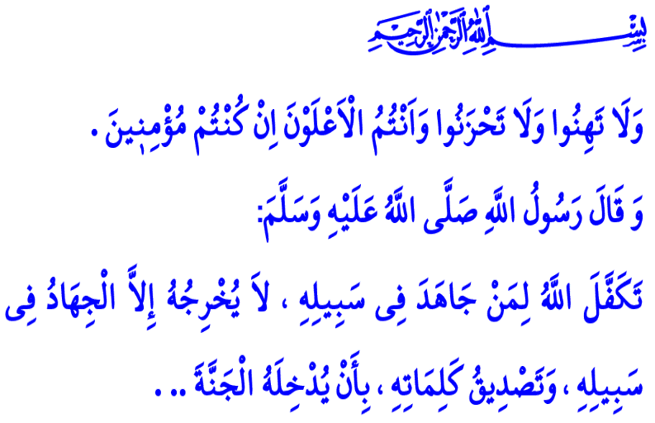
FOR OUR SOLDIERS (MEHMETCIK) ARE ALL OUR PRAYERS
Dear Muslims!
In this blessed hour when the prayers are accepted, I would like to mention about someone I know. A young man who is ready to give up on everything when it comes down to the defense of homeland...
You know him as well, he is the hero whom we named after the Prophet Muhammad (saw), the Honor of the Universe, thus "Mehmetçik"... Some of you may recognize him from the history. A strong, bold, intelligent, skillful, and fearless young man... Always up for fighting on the forefront... Restlessly, tirelessly... While rushing from one battlefield to another, he would sometimes leave behind his leg, sometimes his arm, and sometimes his eyes; yet, he would always hold the love for the homeland on the forefront, and say, “All for the homeland to live long!”
Dear Muslims!
The Prophet Muhammad (saw) said, “Allah guarantees to the person who carries out Jihad for His Cause and nothing compelled him to go out but the Jihad in His Cause, and belief in His Words, that He will either admit him into Paradise or return him with his reward or the booty he has earned to his residence from where he went out.” With this glad tiding in mind, our Mehmetçik has hit the road once again. Out of seasons he loves spring the most; out of months August; but, he walked on these days of October as well. To bring peace to those victimized by terrorism, to bring tranquility to those at unease, to lighten those whose hearts are in flames...
Calling his walk “Peace Spring”. Together with his friends, relatives, brothers... They are the sons of some of us, the brothers of some others... They are the sons of all of us, and the apples of our eyes...
Dear Believers!
Mehmetçik keeps walking day and night, regardless of time and place... Mehmetçik rewrites the history with his sweat and blood. Along the borders he protects, not only is our homeland safe, but also the fate of humanity is saved from chaos.
The verse “So do not weaken and do not grieve, and you will be superior if you are true believers.” in the Holy Qur'an gives hope to our heroic army in this walk of peace in such a struggle for the better of humanity. This is such a great faith and love for homeland that the Holy Qur'an describes those who were martyred for this love as, “And never think of those who have been killed in the cause of Allah as dead. Rather, they are alive with their Lord, receiving provision, rejoicing in what Allah has bestowed upon them of His bounty.”

Dear Brothers and Sisters!
There is no doubt that with the help of Allah (swt), the plans of treachery will be disrupted, the traps and cheats of the oppressors will become thorn in their own sides. As Mehmetçik guards the entrenchments, the dreams and plans of all our enemies and their servants who infiltrated among us will confront with our reality, their traps with our faith, and they will be drowned in their own flood of terrorism that they pump. As our army moves forward and progresses for the cause of peace, all the innocent, the women and the children will gain safety and peace under the shade of our flag.
Dear Believers!
Mehmetcik is the star shining above us, our gem and treasure on earth under the shadow of our flag... Our heroic saga as one heart and one soul for the homeland, flag, nation, and state... On the front for the good to prevail the world and for the sake of humanity. And all our prayers are for them while they are rushing and struggling, shoulder to shoulder, on the land or in the air whether near or far, for the oppressed and the victimized who are deprived of their rights and freedoms May their sweat become mercy; may their blood become grace... For them are all our recitations of the Surah al-Ya-Sin, al-Fath, and al-Fatihah... And for them are all our utterances of amin.
Amin! O Allah, al-Aziz and al-Karim! O Allah, al-Rahman and al-Rahim! Here we are at Your door, humbly asking Your Highness for help, asking Your Majesty for mercy. By uttering Your name and with our helplessness before Your presence. We ask for Your help for our soldiers and victory for our army. Save their lives from grueling and hazard, and protect their bodies from exhaustion and from being caught off guard.
O Lord, You are Who lets armies exist in the world as per Your name al-Jalal, and You are the Most Beloved, Who lets the martyrs be honored to see Your face in the Hereafter as per Your name al-Jamal. In Your Existence and Oneness we believe, and in You we trust and seek refuge. Do not let the Muslim ummah be challenged among themselves, and let not the innocent get burnt in the flames of sedition. Save the oppressed from the darkness, wake those deeply asleep in negligence up from the morningless nights... Do not make our friends sadden, do not make our enemies happy in this road. Do not cease Your mercy on our heroic army, do not take away Your divine abundance of blessings from our heavenly homeland. Make us sure about what we worry, and make us the representatives of Islam illuminating the darkness in tough times. Frustrate and destroy the masters and the servants of terrorism, set those oppressors against each other.
O Allah, Who is above all defects! Bestow Your blessings upon our martyrs, and bestow speedy recovery upon our wounded soldiers. Ease the pain and griefs of those who in pain, and bless our hopes with victory! Treat our prayers as those made in the Ka'bah. We are begging You not to take away Your compassion from us, not to withhold Your mercy from us... O Allah, do not silence our adhans. Do not let anybody and anything divide our homeland, o Allah! Do not let anybody pull our flag down the pole, o Allah! Do not let us bow down to anybody but You, o Allah, protect our soldiers from any kind of evil and harm! Let them gain victory and turn back safe and sound with glory and peace as soon as possible. I wish our mercy to our martyrs and veterans who founded our state and made this land our homeland. Amin, all praise and thanks be to Allah…

Bukhari, Tawhid, 28.
Al-i 'Imran, 3/139.
Al-i 'Imran, 3/169-170. General Directorate of Religious Services

